Instructions for Students:
- Complete this report during the 30-minute in-class test.
- Take screenshots for all outputs as evidence.
- Fill in all commands, IP addresses, and observations in the respective sections.
- Submit the completed report along with screenshots in Moodle immediately after the test

COIT12206 – Week 3 Lab Report Template
Max Duration: 30 minutes | Max Marks: 10
Student Name: Michael Hall
Student ID: 12091677
Tutorial Group: Distance
Date of Lab: 25/03/2026

Task 1
1. Network Topology
Network Diagram / Screenshot:
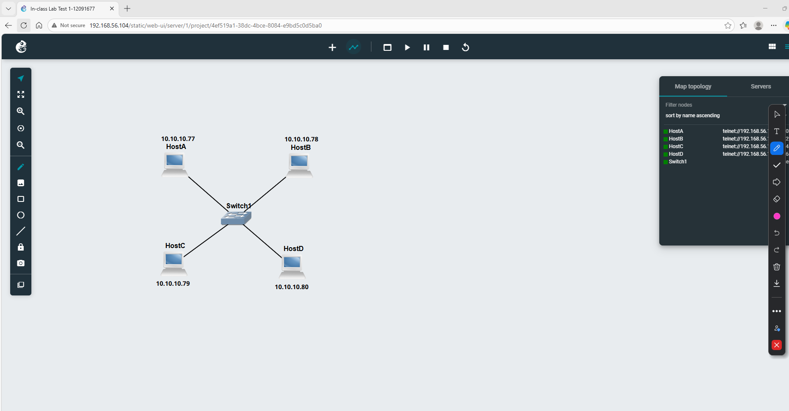

2. IP Configuration Steps
- Screenshot
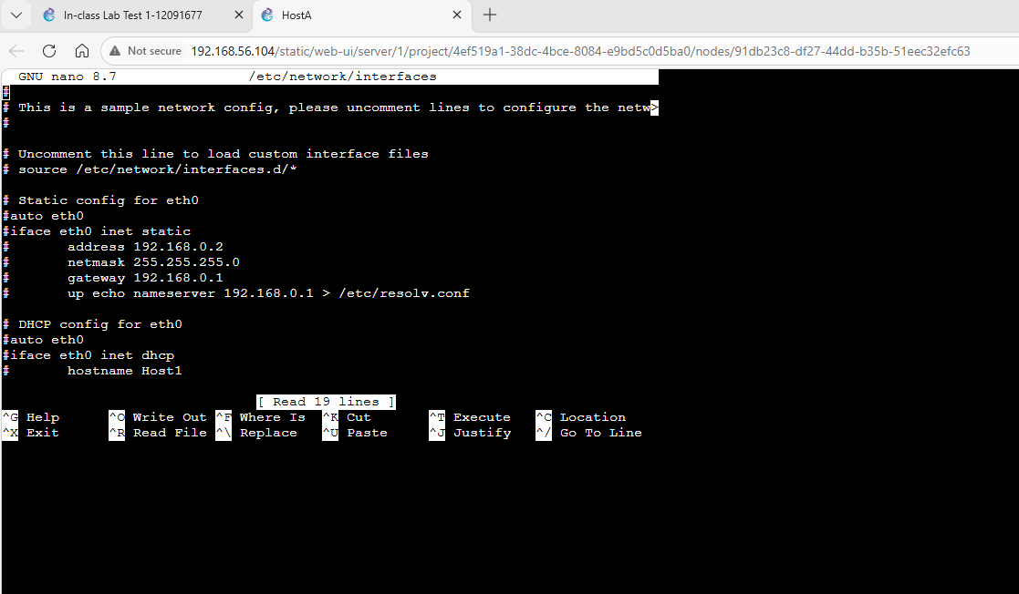
Configuration using the nano /etc/network/interfaces command
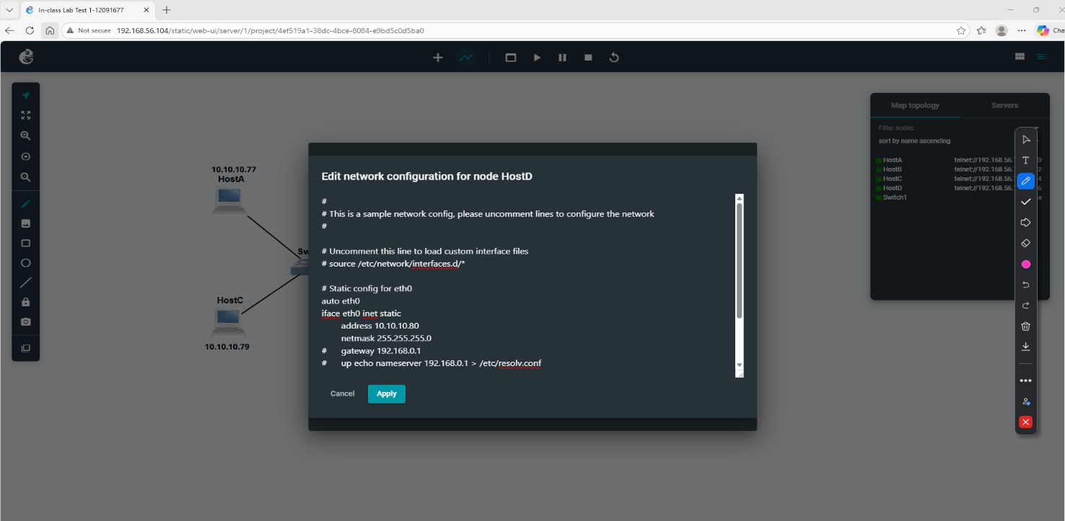
Configuration using the GNS3 menu

2. Static IP (ip command):
- Screenshot
- 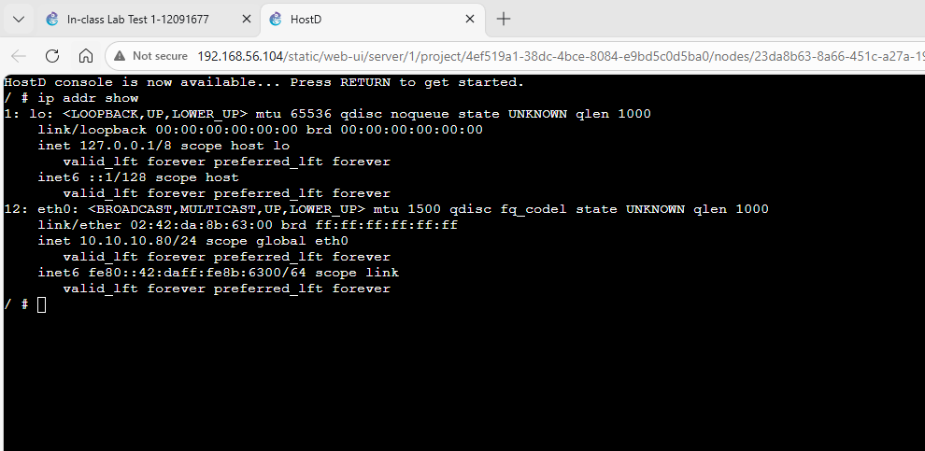

Task 2
3. Connectivity Testing (Ping)
- Screenshot
- 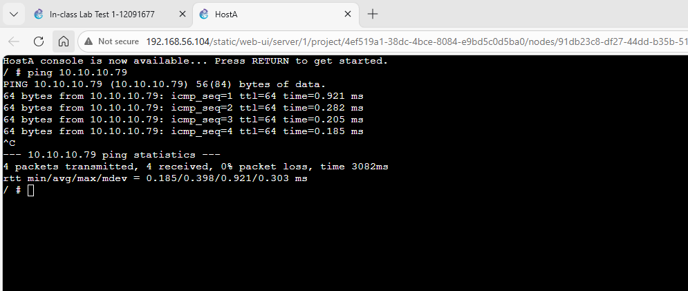

- Screenshot
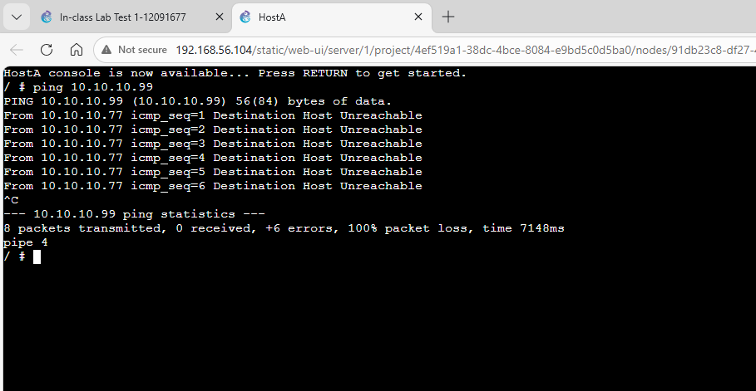

- Screenshot
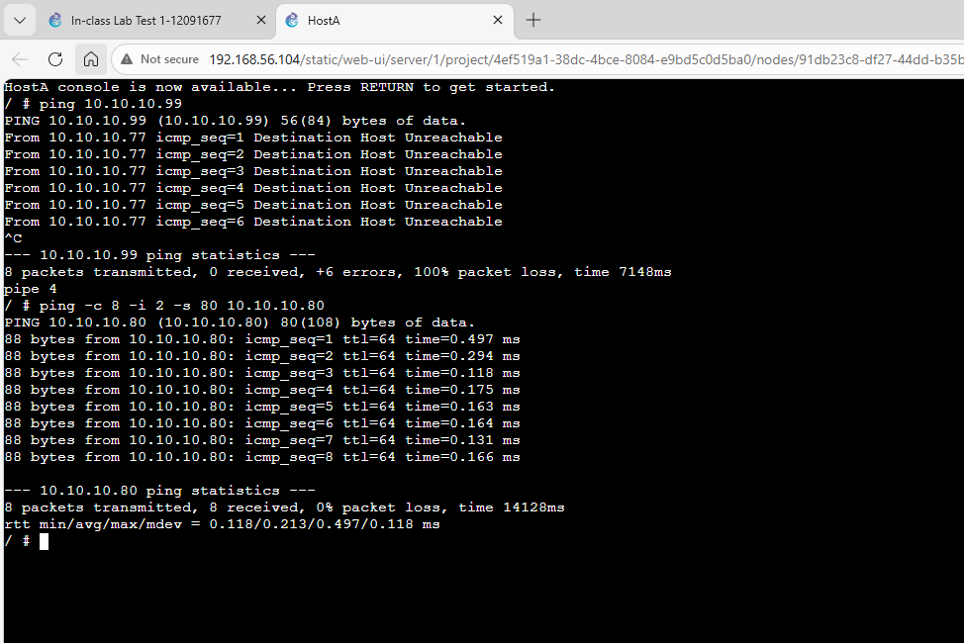
Screenshot using a 8x ping, interval of 2ms and a sizer of 80bytes
Task 3
4. Observations / Issues
- Issues encountered during configuration:
The only issues I faced was when I used the console to configure the static IP and forgot to use the ifup eth0 command to turn the ethernet port on.
- Solutions applied:
Simply turning the host on and then off agin and using the ‘ip addr show’ command fixed this probleem
5. Reflection / Learning
- What did I learn from today’s lab?
Todays lab I learned that if I forgot to turn the ethernet port on you can restart and it will come on automatically.

- Which commands or tools were most useful?
I found the ip addr show and ping commands most useful and used, especially when using the ping with size and interval options.

